Date:18.02.2022

**Third Year B. Tech., Sem VI 2021-22**

**Advanced Database System Lab**

**Assignment submission**

**PRN No: 2019BTECS00064**

**Full name: Kunal Santosh Kadam**

**Batch: T2**

**Assignment: 8**

**Title of assignment: Install & configure Oracle Advanced Replication server.**

Install & configure Oracle Advanced Replication server. Use Oracle Enterprise Edition for multiple master sites.

Write Python desktop application to demonstrate the CRUD operations on replica server.

Use sample STUDENT Database from:

<http://www.oraclesqlbyexample.com/download-the-sample-database.html>

Ans:

Installing Oracle GoldenGate for 19c Database Edition:

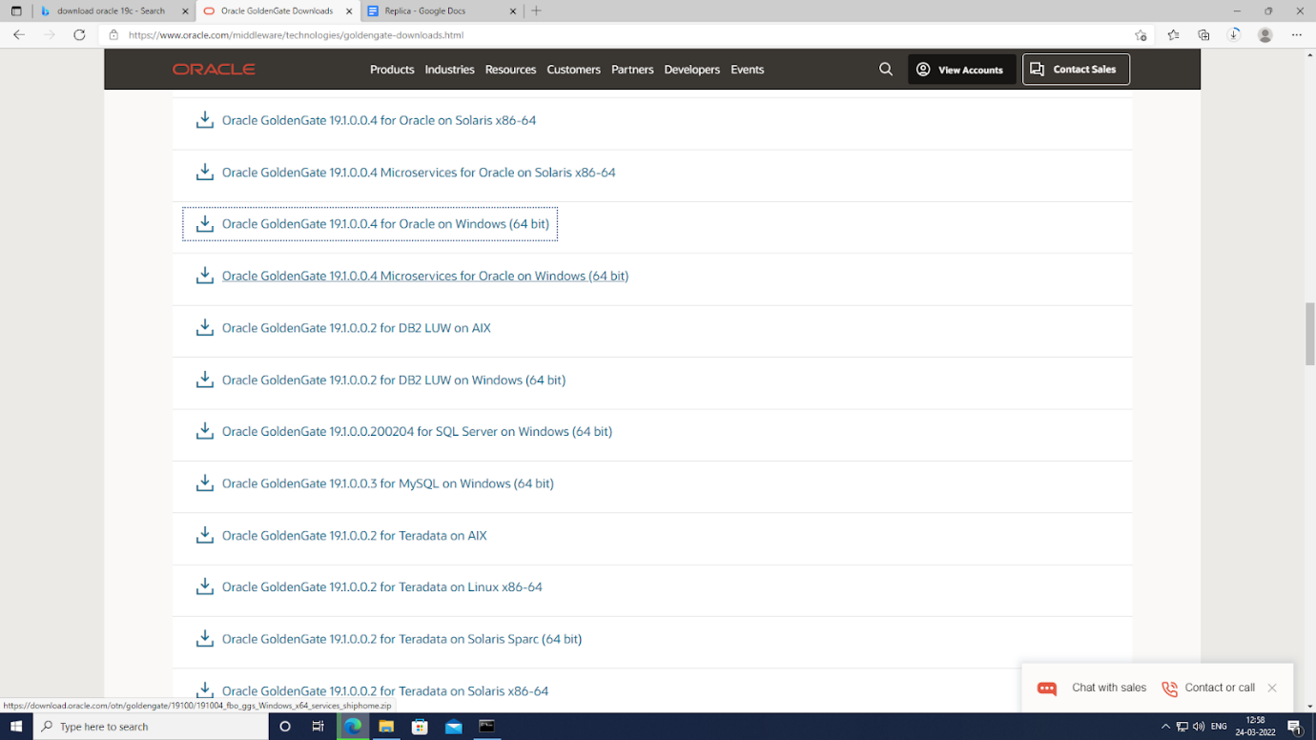

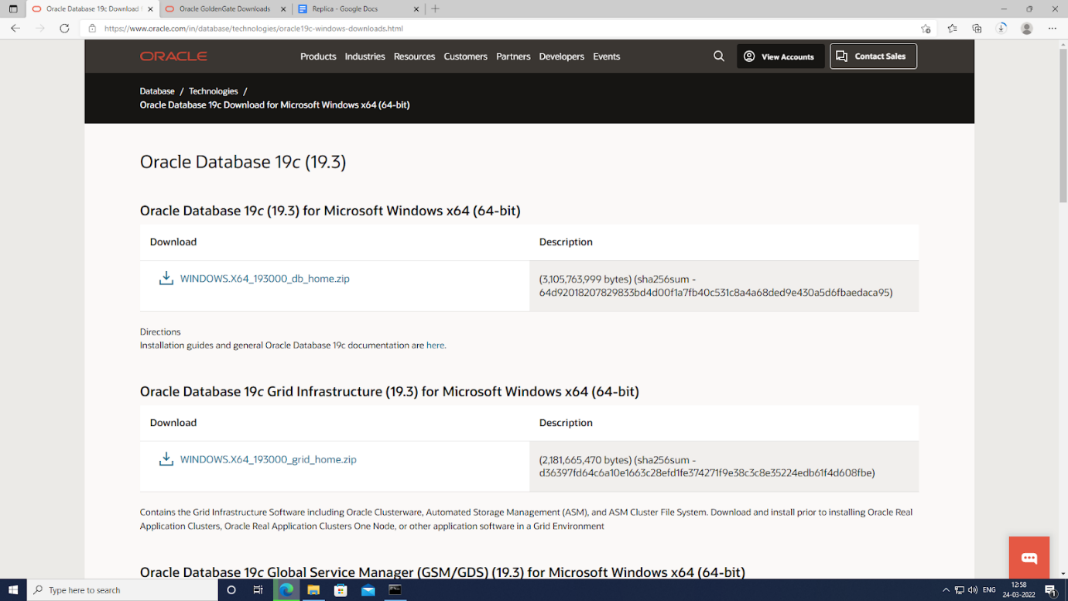

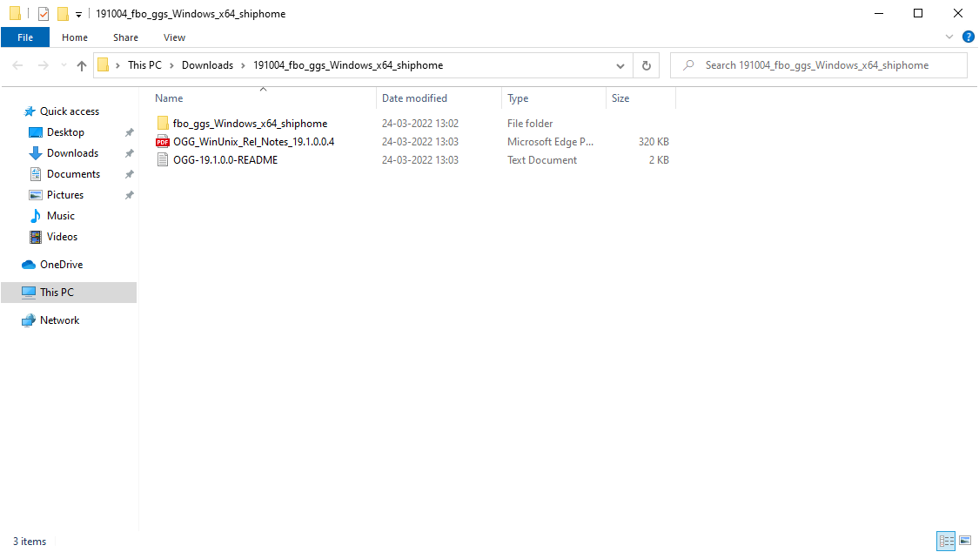

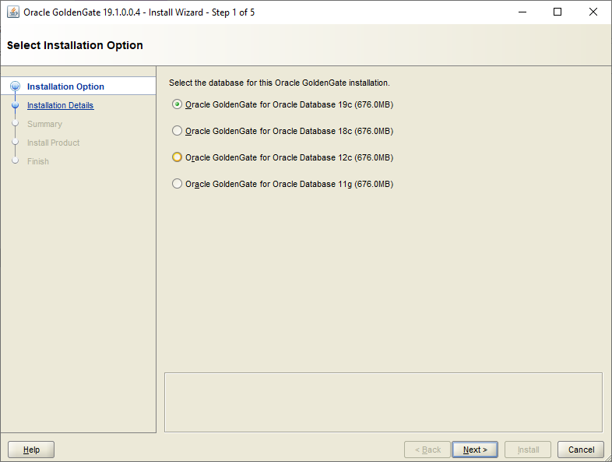

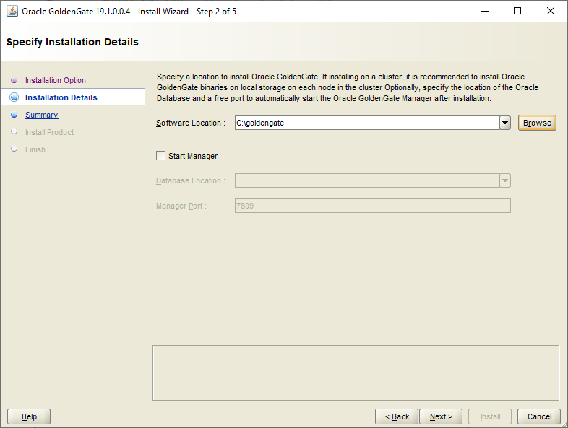

Setting ORACLE_HOME and ORACLE_SID path in system environment variables:

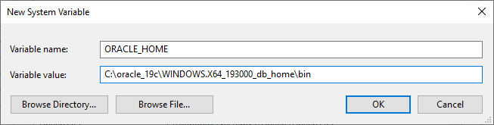

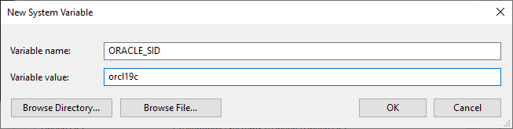

Logging in to the Oracle 19c Database:

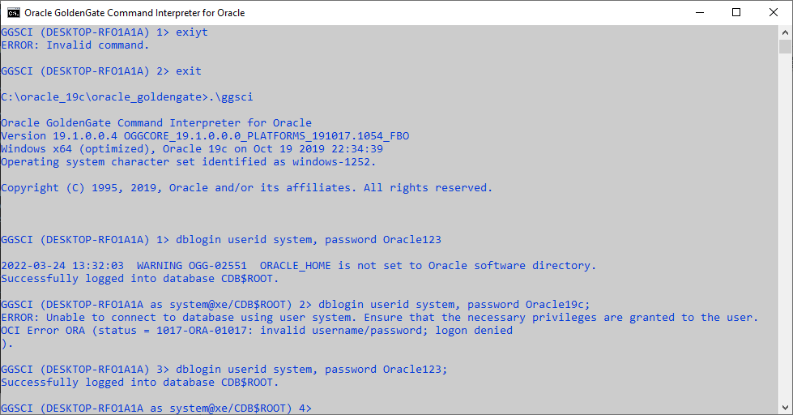

Creating Student Schema:

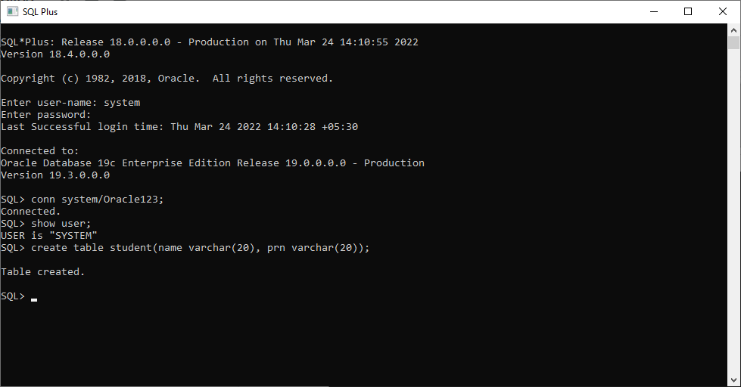

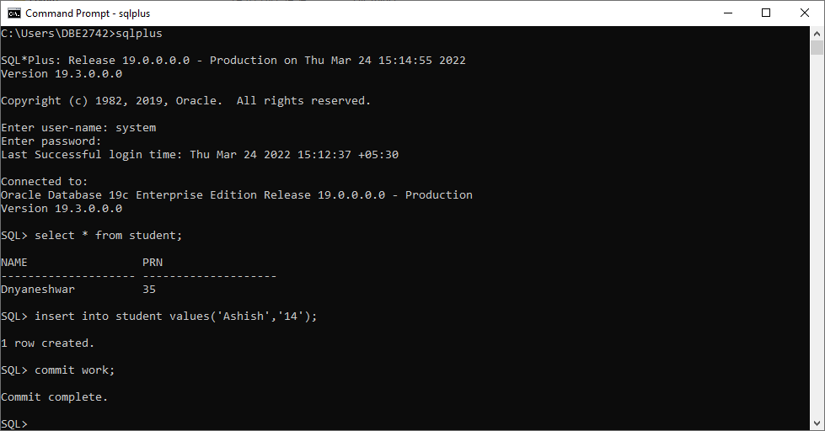

Creating Student Schema on node 2:

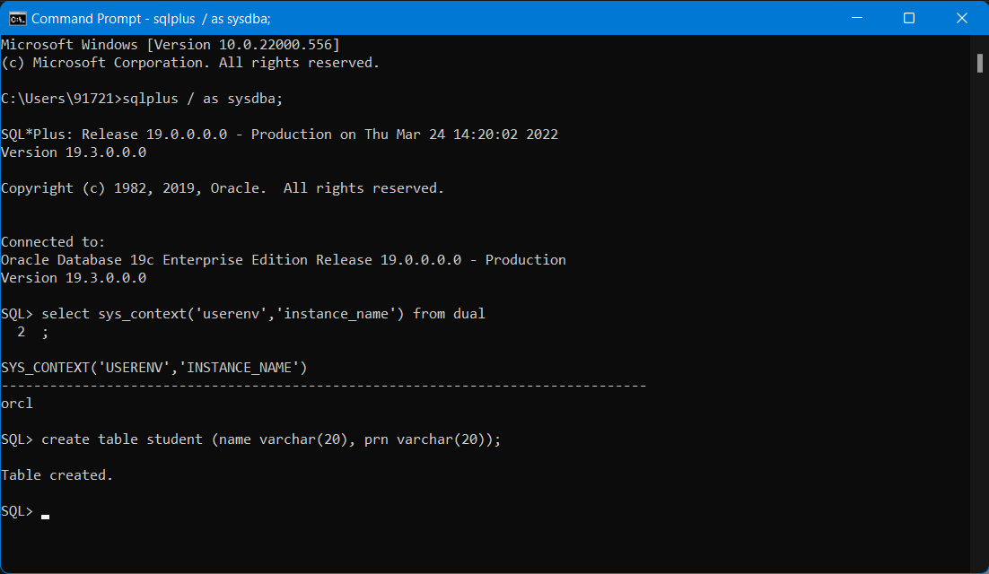

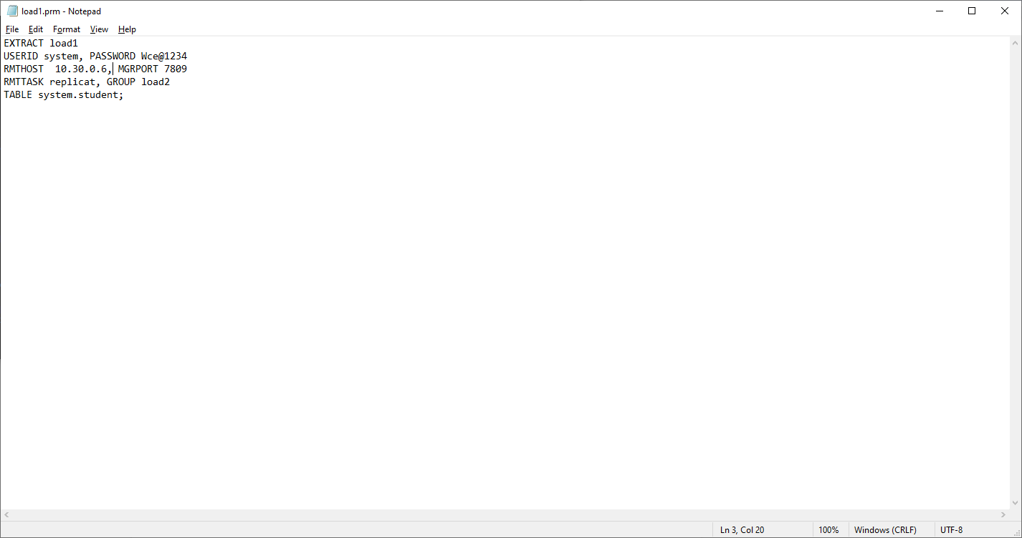

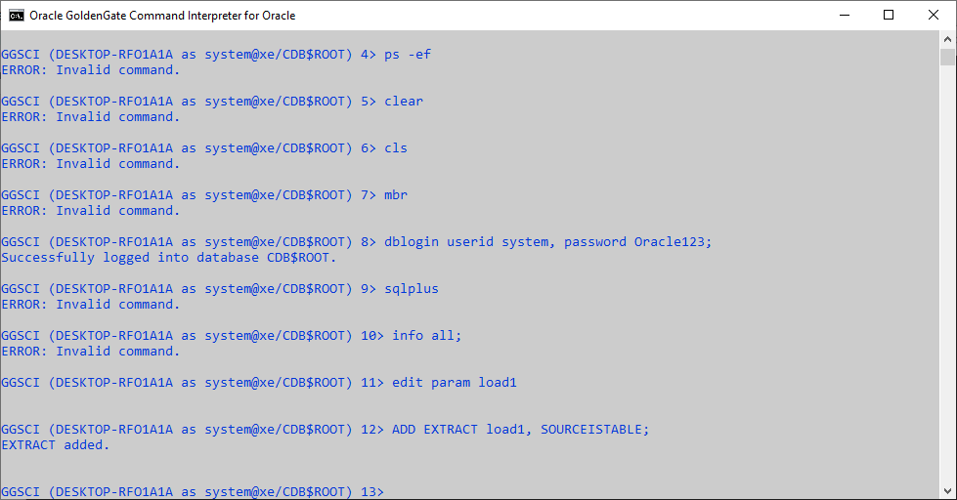

Creating an Replicate on client Node:

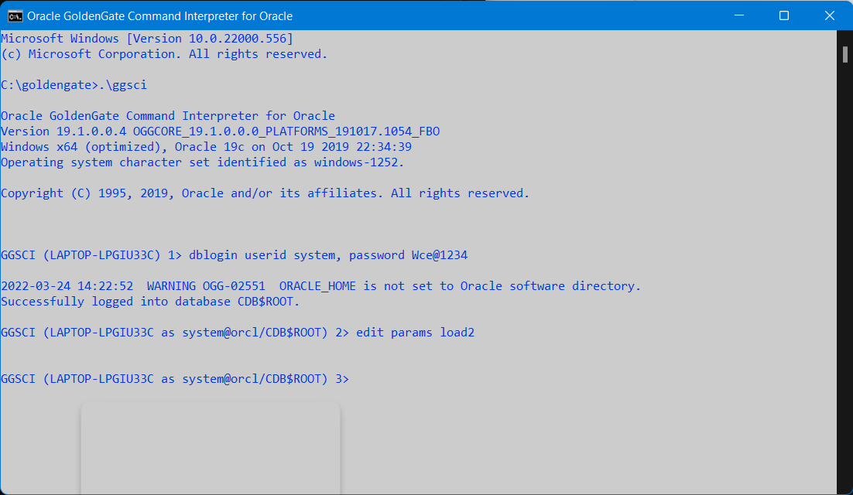

Creating Replicate on Node 2:

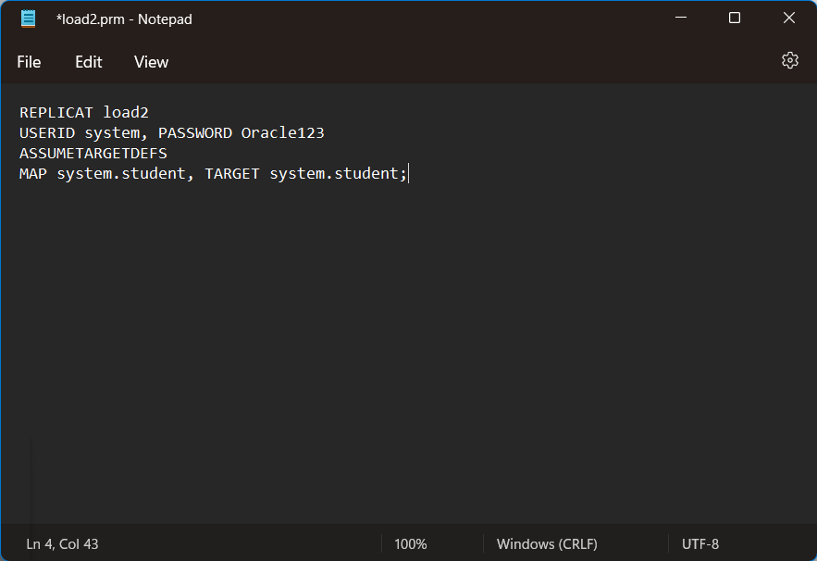

Time Zone Error on Node 2:

